
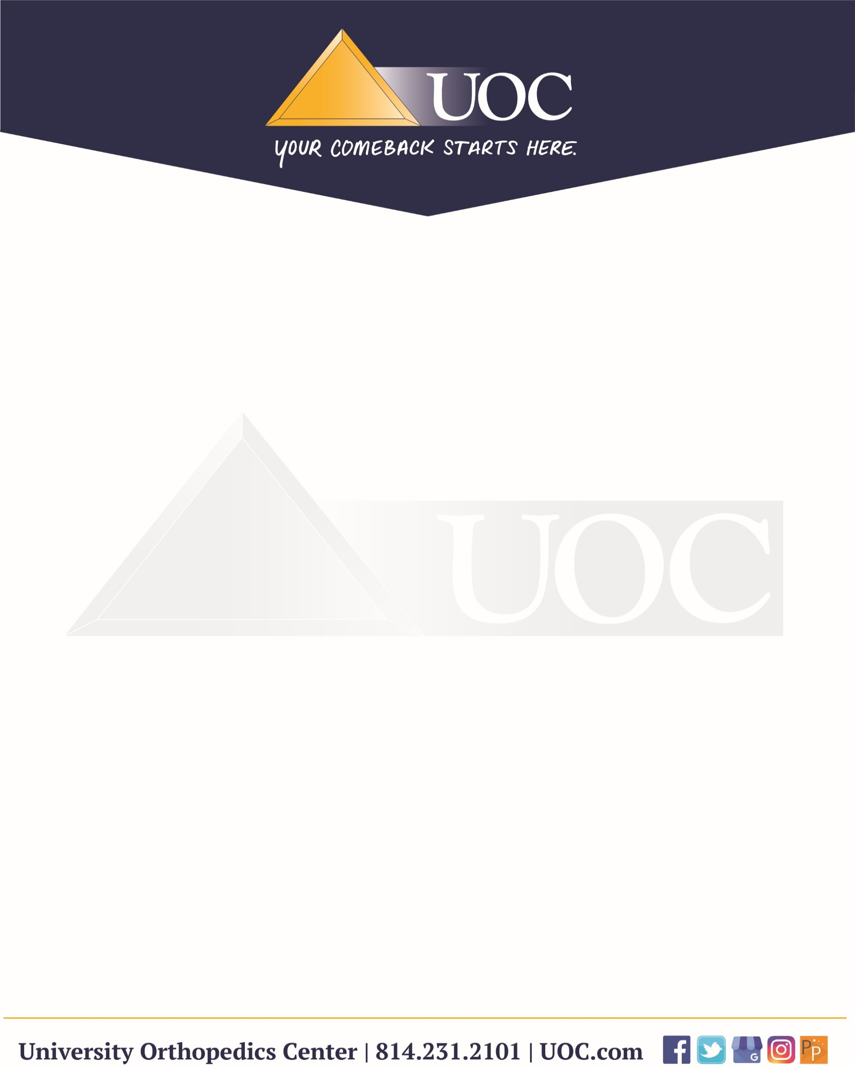

From your surgeon-Total Hip Replacement AFTER Surgery Instructions:
Your Incision and Dressing Care
You will leave surgery with one dressing – either Silverlon or PICO dressing. Follow the instructions for the type of dressing you have.

Silverlon Dressing
- The Silverlon dressing stays on for 7 days.
- It should only be changed if it becomes soaked – meaning the entire rectangle is filled with blood not just partially soaked.
- If it is not completely soaked or leaking, leave it on for the full 7 days.
- If it does need to be changed, replace it with gauze and tape (you will only receive one SIlverlon dressing.)
- Remember – it is just a big band-aid! It is easy to remove.
Showering with Silverlon Dressing
- You may shower after 2 days if the Silverlon is still in place (it is water resistant, not spa proof).
- If the Silverlon had to be removed for Day 0-4, wait until Day 5 before showering.
- Take quick showers, no long soaks or baths.
Drain (If you have one)
- Remove the drain when output is less than 20 cc for two 12-hour shifts in a row.
- To remove, simply cut the small suture and pull gently – it should come out easily.
PICO Dressing (Smith & Nephew)
- If you have a PICO dressing, you will receive two of them.
  - The first is ready when you leave the place of surgery
  - The second is for later use and provided before discharge.
- The PICO power unit provides gentle suction/compression to help the incision heal.
  - The power supply and dressing each last about 7 days.
Care Instructions for PICO:
- If the dressing becomes soaked or leaks, remove it and throw it away, including the battery/power unit. Remember, it is just a big band-aid. Simply remove.
- Then place the second PICO dressing on like a band-aid. If tubing is attached, you can cut and discard – it is not needed for the second dressing.
- Ideally, you will 14 total days of protection (7 days per dressing).
- If both dressings fail early, cover the incision with gauze and tape.

Page 1

*If the PICO battery beeps or drives you crazy, simply cut the tube and throw it away – no need for permission to do so*

Showering with PICO dressing:
- If the first PICO dressing is removed from day 0-4, wait until day 5 before showering.
- Take quick showers, no long soaks or baths.
*Goal for both dressings is to keep incision covered and protected for 14 days*

Pain, Swelling and Recovery
- ICE AND ELEVATE CONSTANTLY!!!
  - Keep your “TOES ABOVE YOUR NOSE” whenever possible to reduce swelling.
- Follow your “Dos and Don’ts” and other provided educational material.
- Ignore hospital paperwork – only follow the UOC instructions and videos provided by your surgeon.
Medications
You will typically have 6 prescriptions after surgery. Some may already be sent to your pharmacy; others are given the day of surgery.
- Tramadol – For pain relief. State law requires this to be sent day of surgery.
- Aspirin – Take for 30 days to prevent blood clots, unless you were prescribed a stronger blood thinner. (Xarelto, Eliquis, Plavix, etc.)
- Tylenol – For additional pain control, as appropriate.
- Zofran – For nausea. Take as needed; May call if you need a refill.
- Celebrex – For inflammation. May call for refills.
    - If not covered by insurance, use Ibuprofen 600 mg, 2-3 times per day.
    - If you are on a blood thinner (Xarelto, Eliquis, Plavix), wait 2 weeks before restarting Celebrex or Ibuprofen.
- Duricef – Antibiotic for infection prevention. Take as prescribed.
*Optional: Take a probiotic daily during recovery to help prevent diarrhea.
- Available through the UOC Pharmacy (discounted) or any drugstore over-the-counter

Questions or Concerns call UOC first before going to the emergency room. Our team can help address nearly every situation quickly.

UOC Main Line: 814-231-2101

Page 2

